1. Select Your Operating System (OS): Choose an operating system that best suits your preferences and project requirements. Download and Install Windows 11. <https://www.microsoft.com/software-download/windows11>

Answer: installed window 11 and ubuntu 18 on my desktop.

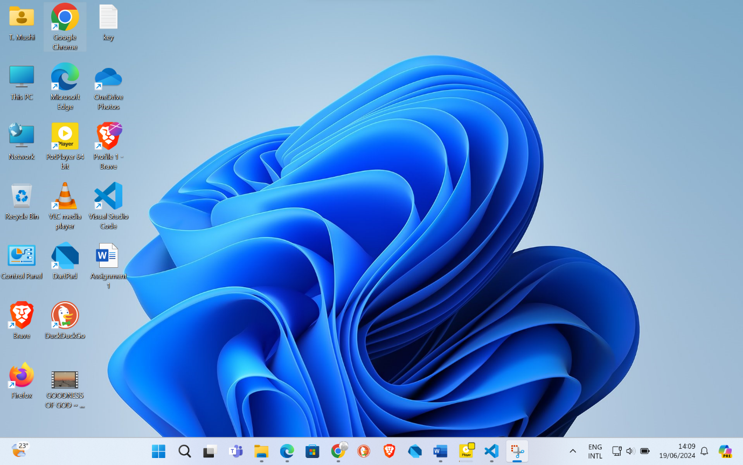

1. Install a Text Editor or Integrated Development Environment (IDE): Select and install a text editor or IDE suitable for your programming languages and workflow. Download and Install Visual Studio Code. <https://code.visualstudio.com/Download>

I installed it

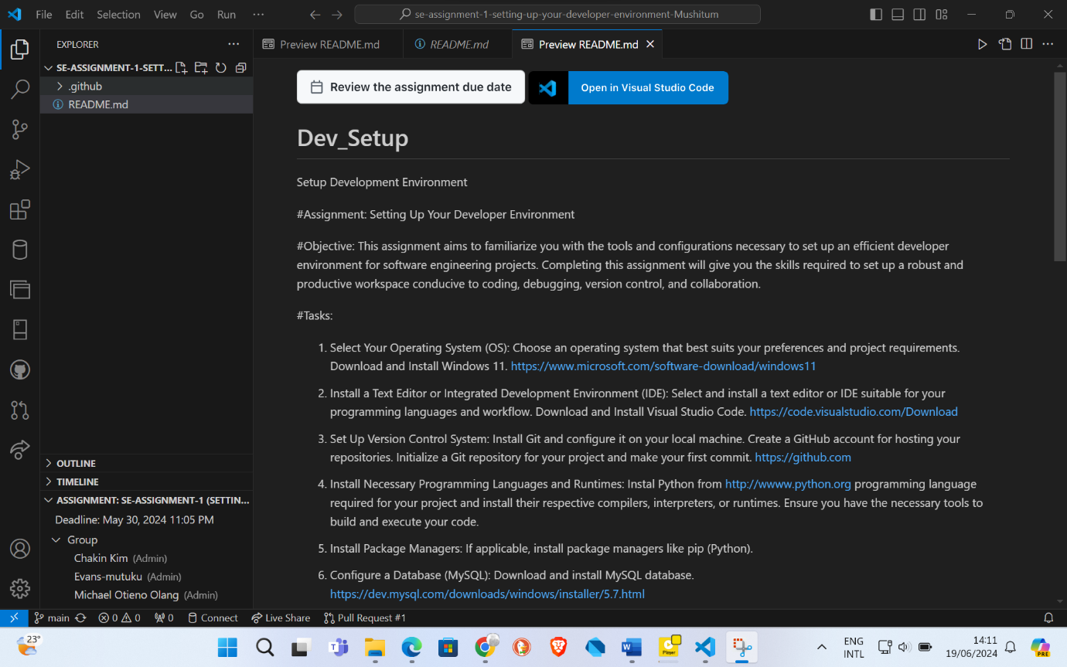

1. Set Up Version Control System: Install Git and configure it on your local machine. Create a GitHub account for hosting your repositories. Initialize a Git repository for your project and make your first commit. [https://github.com](https://github.com/)

Below is git and git hub as I installed:

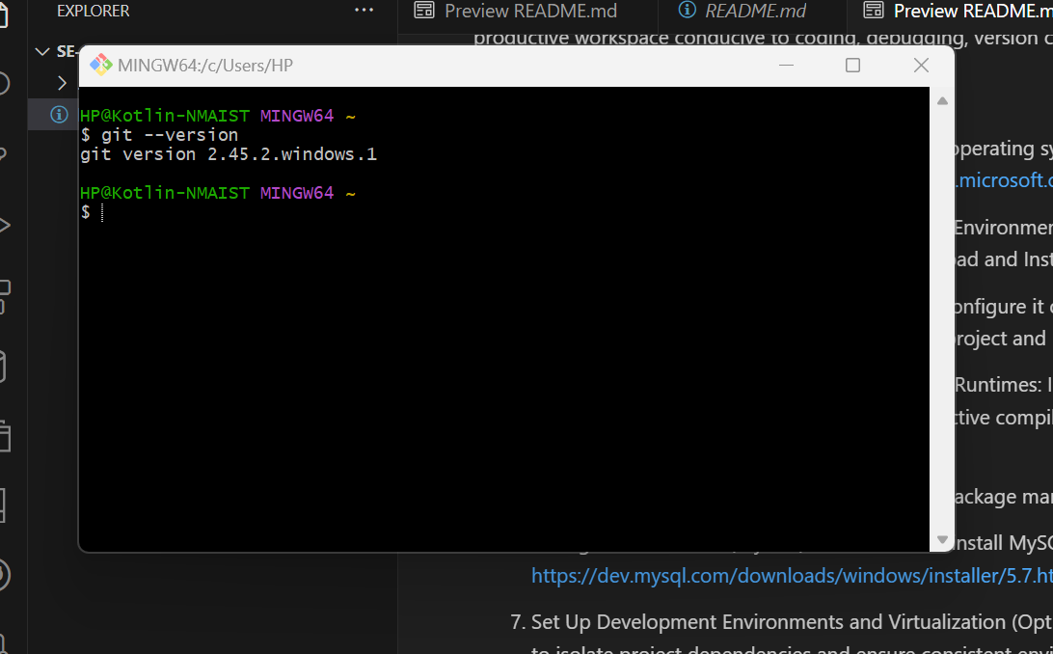

Github:

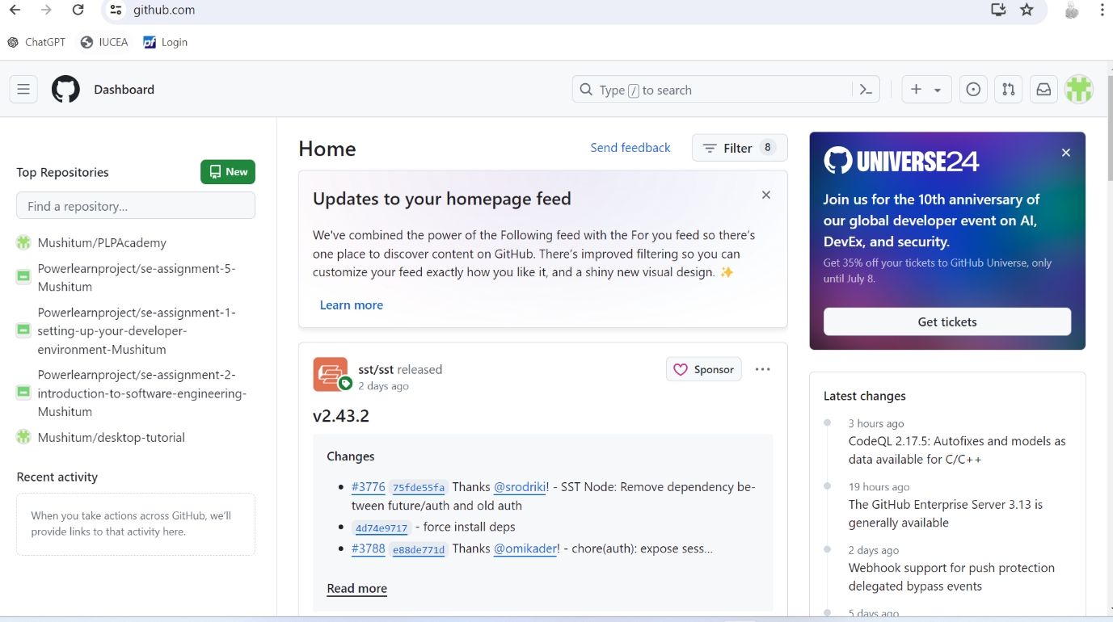

1. Install Necessary Programming Languages and Runtimes: Instal Python from [http://wwww.python.org](http://wwww.python.org/) programming language required for your project and install their respective compilers, interpreters, or runtimes. Ensure you have the necessary tools to build and execute your code.

Python:

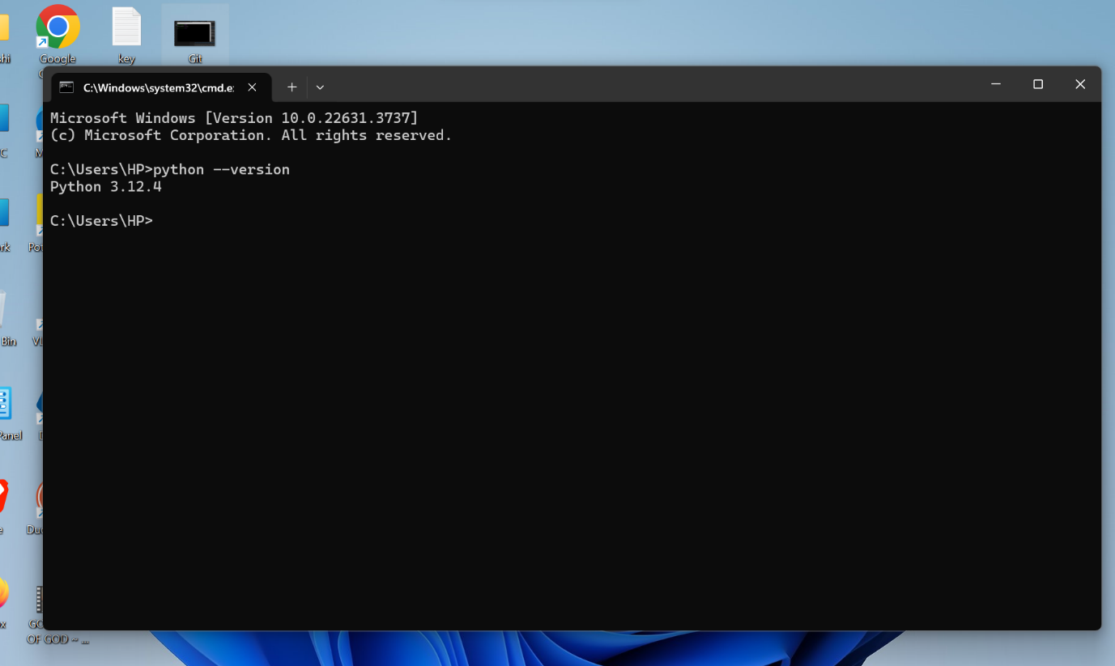

1. Install Package Managers: If applicable, install package managers like pip (Python).
2. Configure a Database (MySQL): Download and install MySQL database. <https://dev.mysql.com/downloads/windows/installer/5.7.html>

Mysql::

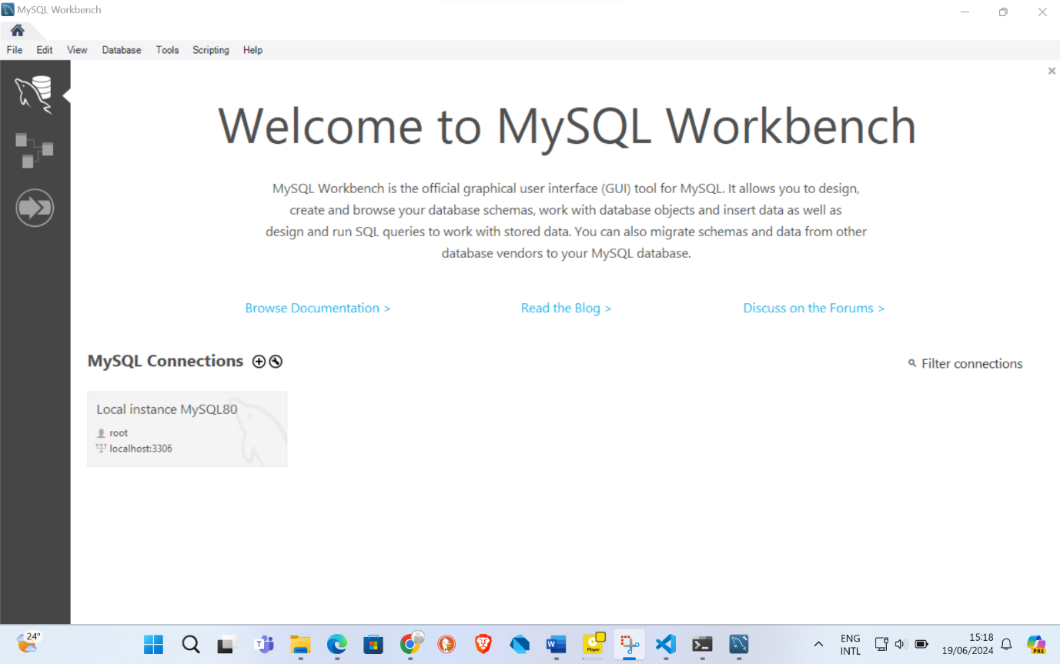

1. Set Up Development Environments and Virtualization (Optional): Consider using virtualization tools like Docker or virtual machines to isolate project dependencies and ensure consistent environments across different machines.
2. Explore Extensions and Plugins: Explore available extensions, plugins, and add-ons for your chosen text editor or IDE to enhance functionality, such as syntax highlighting, linting, code formatting, and version control integration.
3. Document Your Setup: Create a comprehensive document outlining the steps you've taken to set up your developer environment. Include any configurations, customizations, or troubleshooting steps encountered during the process.

#Deliverables:

* Document detailing the setup process with step-by-step instructions and screenshots where necessary.
* A GitHub repository containing a sample project initialized with Git and any necessary configuration files (e.g., .gitignore).
* A reflection on the challenges faced during setup and strategies employed to overcome them.

#Submission: Submit your document and GitHub repository link through the designated platform or email to the instructor by the specified deadline.

#Evaluation Criteria:**

* Completeness and accuracy of setup documentation.
* Effectiveness of version control implementation.
* Appropriateness of tools selected for the project requirements.
* Clarity of reflection on challenges and solutions encountered.
* Adherence to submission guidelines and deadlines.

Note: Feel free to reach out for clarification or assistance with any aspect of the assignment.